What would Zaroff do? Click [HERE!](http://snotes.com/snotes/ss.php?snoteId=59939b5457c956.02964612)

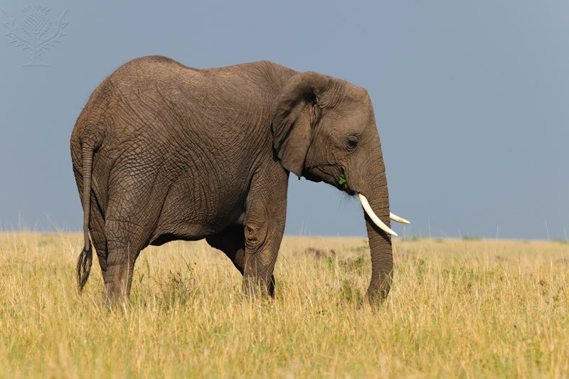 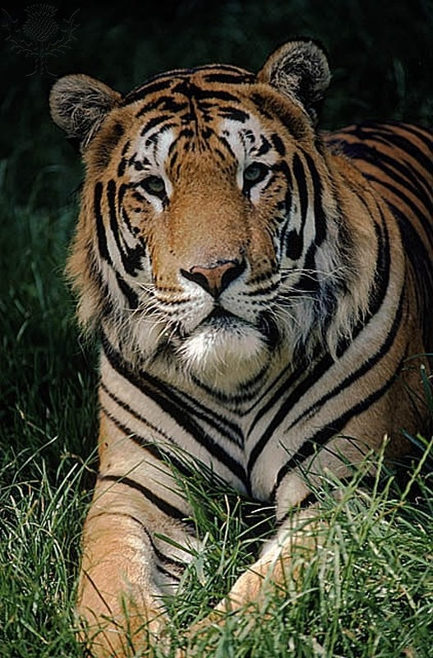

[Elephant](https://www.elephants.com/)

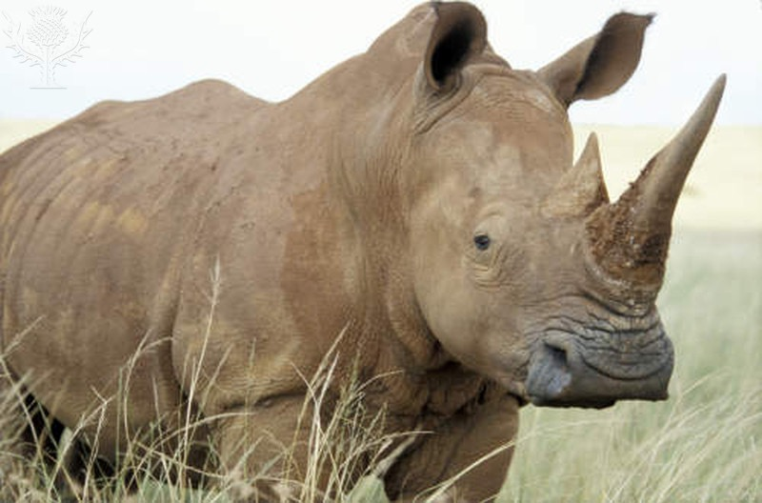

[Rhinocerus](https://docs.google.com/document/d/1XaTUxCfdQxWh4gw0d8yrtlObFN7u1nhFgqbon00qMH8/edit?usp=sharing)

[Tiger](http://www.defenders.org/tiger/basic-facts)

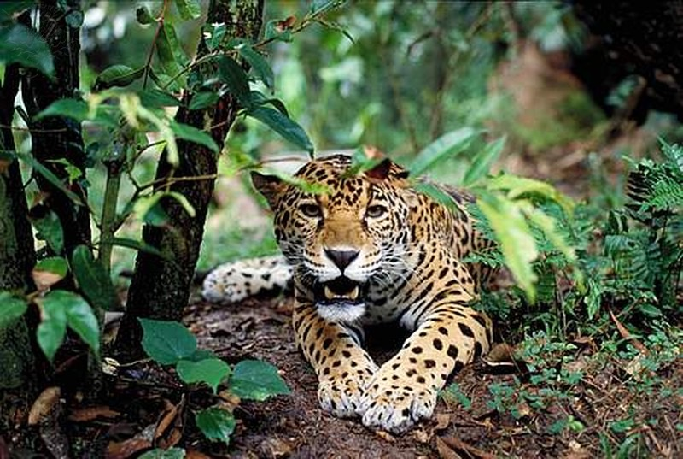 [Jaguar](https://www.panthera.org/cat/jaguar)